**Hands-on Documentation: Mockito Exercise 1**

**Title:**

Mockito – Mocking & Stubbing External Dependencies

**Objective:**

To mock an external API using **Mockito**, stub its method to return test data, and verify service class behavior without hitting real APIs.

**Tools Used:**

* IntelliJ IDEA
* Java 8+
* Maven
* JUnit 5
* Mockito 5.12.0

**Steps Performed:**

**Created ExternalApi Interface**

public interface ExternalApi {

String getData();

}

**Created MyService Class with Dependency Injection**

public class MyService {

private ExternalApi api;

public MyService(ExternalApi api) {

this.api = api;

}

public String fetchData() {

return api.getData();

}

}

**Created MyServiceTest with Mockito**

@Test

public void testExternalApi() {

ExternalApi mockApi = Mockito.mock(ExternalApi.class);

when(mockApi.getData()).thenReturn("Mock Data");

MyService service = new MyService(mockApi);

String result = service.fetchData();

assertEquals("Mock Data", result);

}

**Output:**

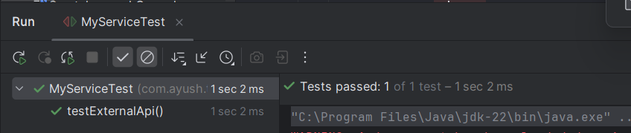

**Conclusion:**

* Learned how to use **Mockito** for mocking interfaces.
* Stubbed a method using when(...).thenReturn(...).
* Tested MyService class in isolation without a real API.